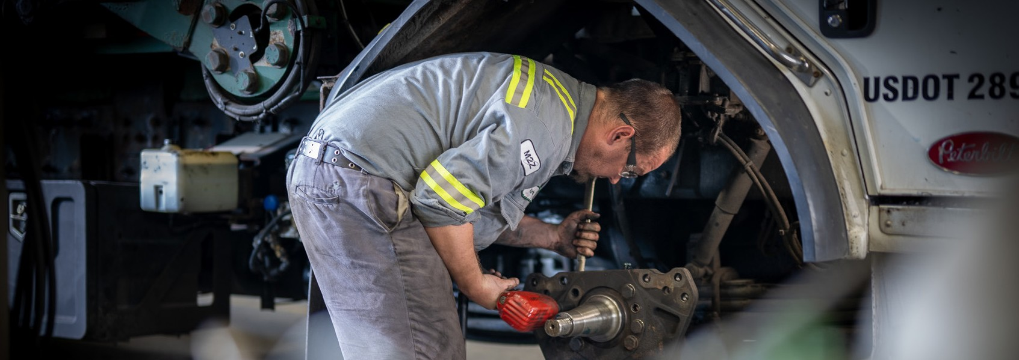

Hiring Today, **For Tomorrow®**

Now Hiring Journeyman Mechanics

Job# 2307373 Location: Prince George, BC

**ROLE HIGHLIGHTS:**

* Sign on Bonus: $8,000
* Hourly Pay Wage: $40.00
* Shift: Monday - Friday - 10:00 am - 6:00 pm
* Travel Time: 20%
* Experience: Four (4) years of relevant work experience.

**WHY JOIN WM?**

Our crews are the best. Highly trained, safety focused, with career opportunities and stability. We invest in you by providing industry-leading benefits- 100% free education for employees and dependents, health coverage, lucrative 401k, stock purchase plan, and more.

Join us, and together, we’ll work proud for our communities.

Ready to start your tomorrow, today?



wm.com/Careers #WeAreWM

As an EEO/Affirmative Action Employer, all qualified applicants will receive consideration for employment without regard to race, color, religion, sex, sexual orientation, gender identity, age, national origin, disability, or veteran status.